# DB2 commands on AWS EC2 machine

## DB2 Database and schema creation

1. Connect to AWS EC2 machine [ec2-user@172.18.2.29](mailto:ec2-user@172.18.2.29).
2. Switch to user “db2inst2” by running below command

sudo su - db2inst2

1. Execute below command to create database “TestCat”

db2 "create database testcat"

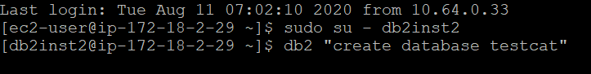

1. Execute below command to create schema “TestSchemaOther”

db2 "create schema TestSchemaOther";



Steps to create a user

1. Login to AWS EC2 instance
2. Change user to root by executing below commands

sudo su –

1. Add a new user “harvestertestuser” by executing below commands

useradd harvestertestuser

1. Add the password for the user by executing below commands

passwd harvestertestuser

## Steps to Grant Permission to a user to create database objects

1. Switch to user “db2inst2” by running below command

sudo su - db2inst2

1. Connect to database by running below command

db2 connect to testcat

1. Grant “DBADM” i.e. admin permission to user by executing below commands

db2 "grant DBADM on DATABASE to user harvestertestuser"

## Steps to connect to database with user

1. Switch to user “db2inst2” by running below command

sudo su - db2inst2

1. Connect to database “testcat” with user “harvestertestuser” by executing below command

db2 connect to testcat user harvestertestuser

1. Execute below command to display server output on console

db2 set serveroutput on

## Steps to drop database objects i.e. Table, View, Procedure, Function and Trigger

1. Connect to database with user “harvestertestuser”
2. Execute below command to drop database object except database

call DROPOBJECTS()

Note: DROPOBJECTS is a procedure which carries drop statements for database objects

Steps to drop schema and drop procedure

1. Terminate the existing connection by executing below commands

db2 terminate

1. Connect to database by running below command

db2 connect to testcat

1. Drop the procedure “DropObjects” by executing below commands

db2 "DROP PROCEDURE harvestertestuser.DropObjects"

1. Drop the schema harvestertestuser with below command

db2 drop schema harvestertestuser RESTRICT

1. Drop the schema TestSchemaOther with below command

db2 drop schema TestSchemaOther RESTRICT

1. Drop the user harvestertestuser with below command

db2 "revoke DBADM on DATABASE from user harvestertestuser"

## Steps to drop database

Execute below command to drop database “testcat”

db2 terminate;

db2 "drop database testcat "